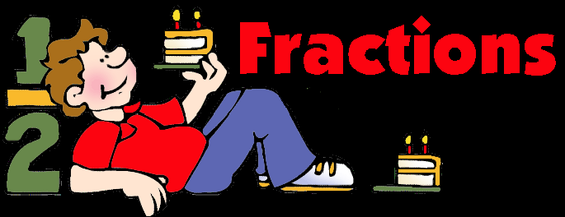
2. Split a whole object into smaller parts.

Assessment Information Block:__________
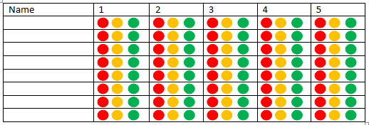
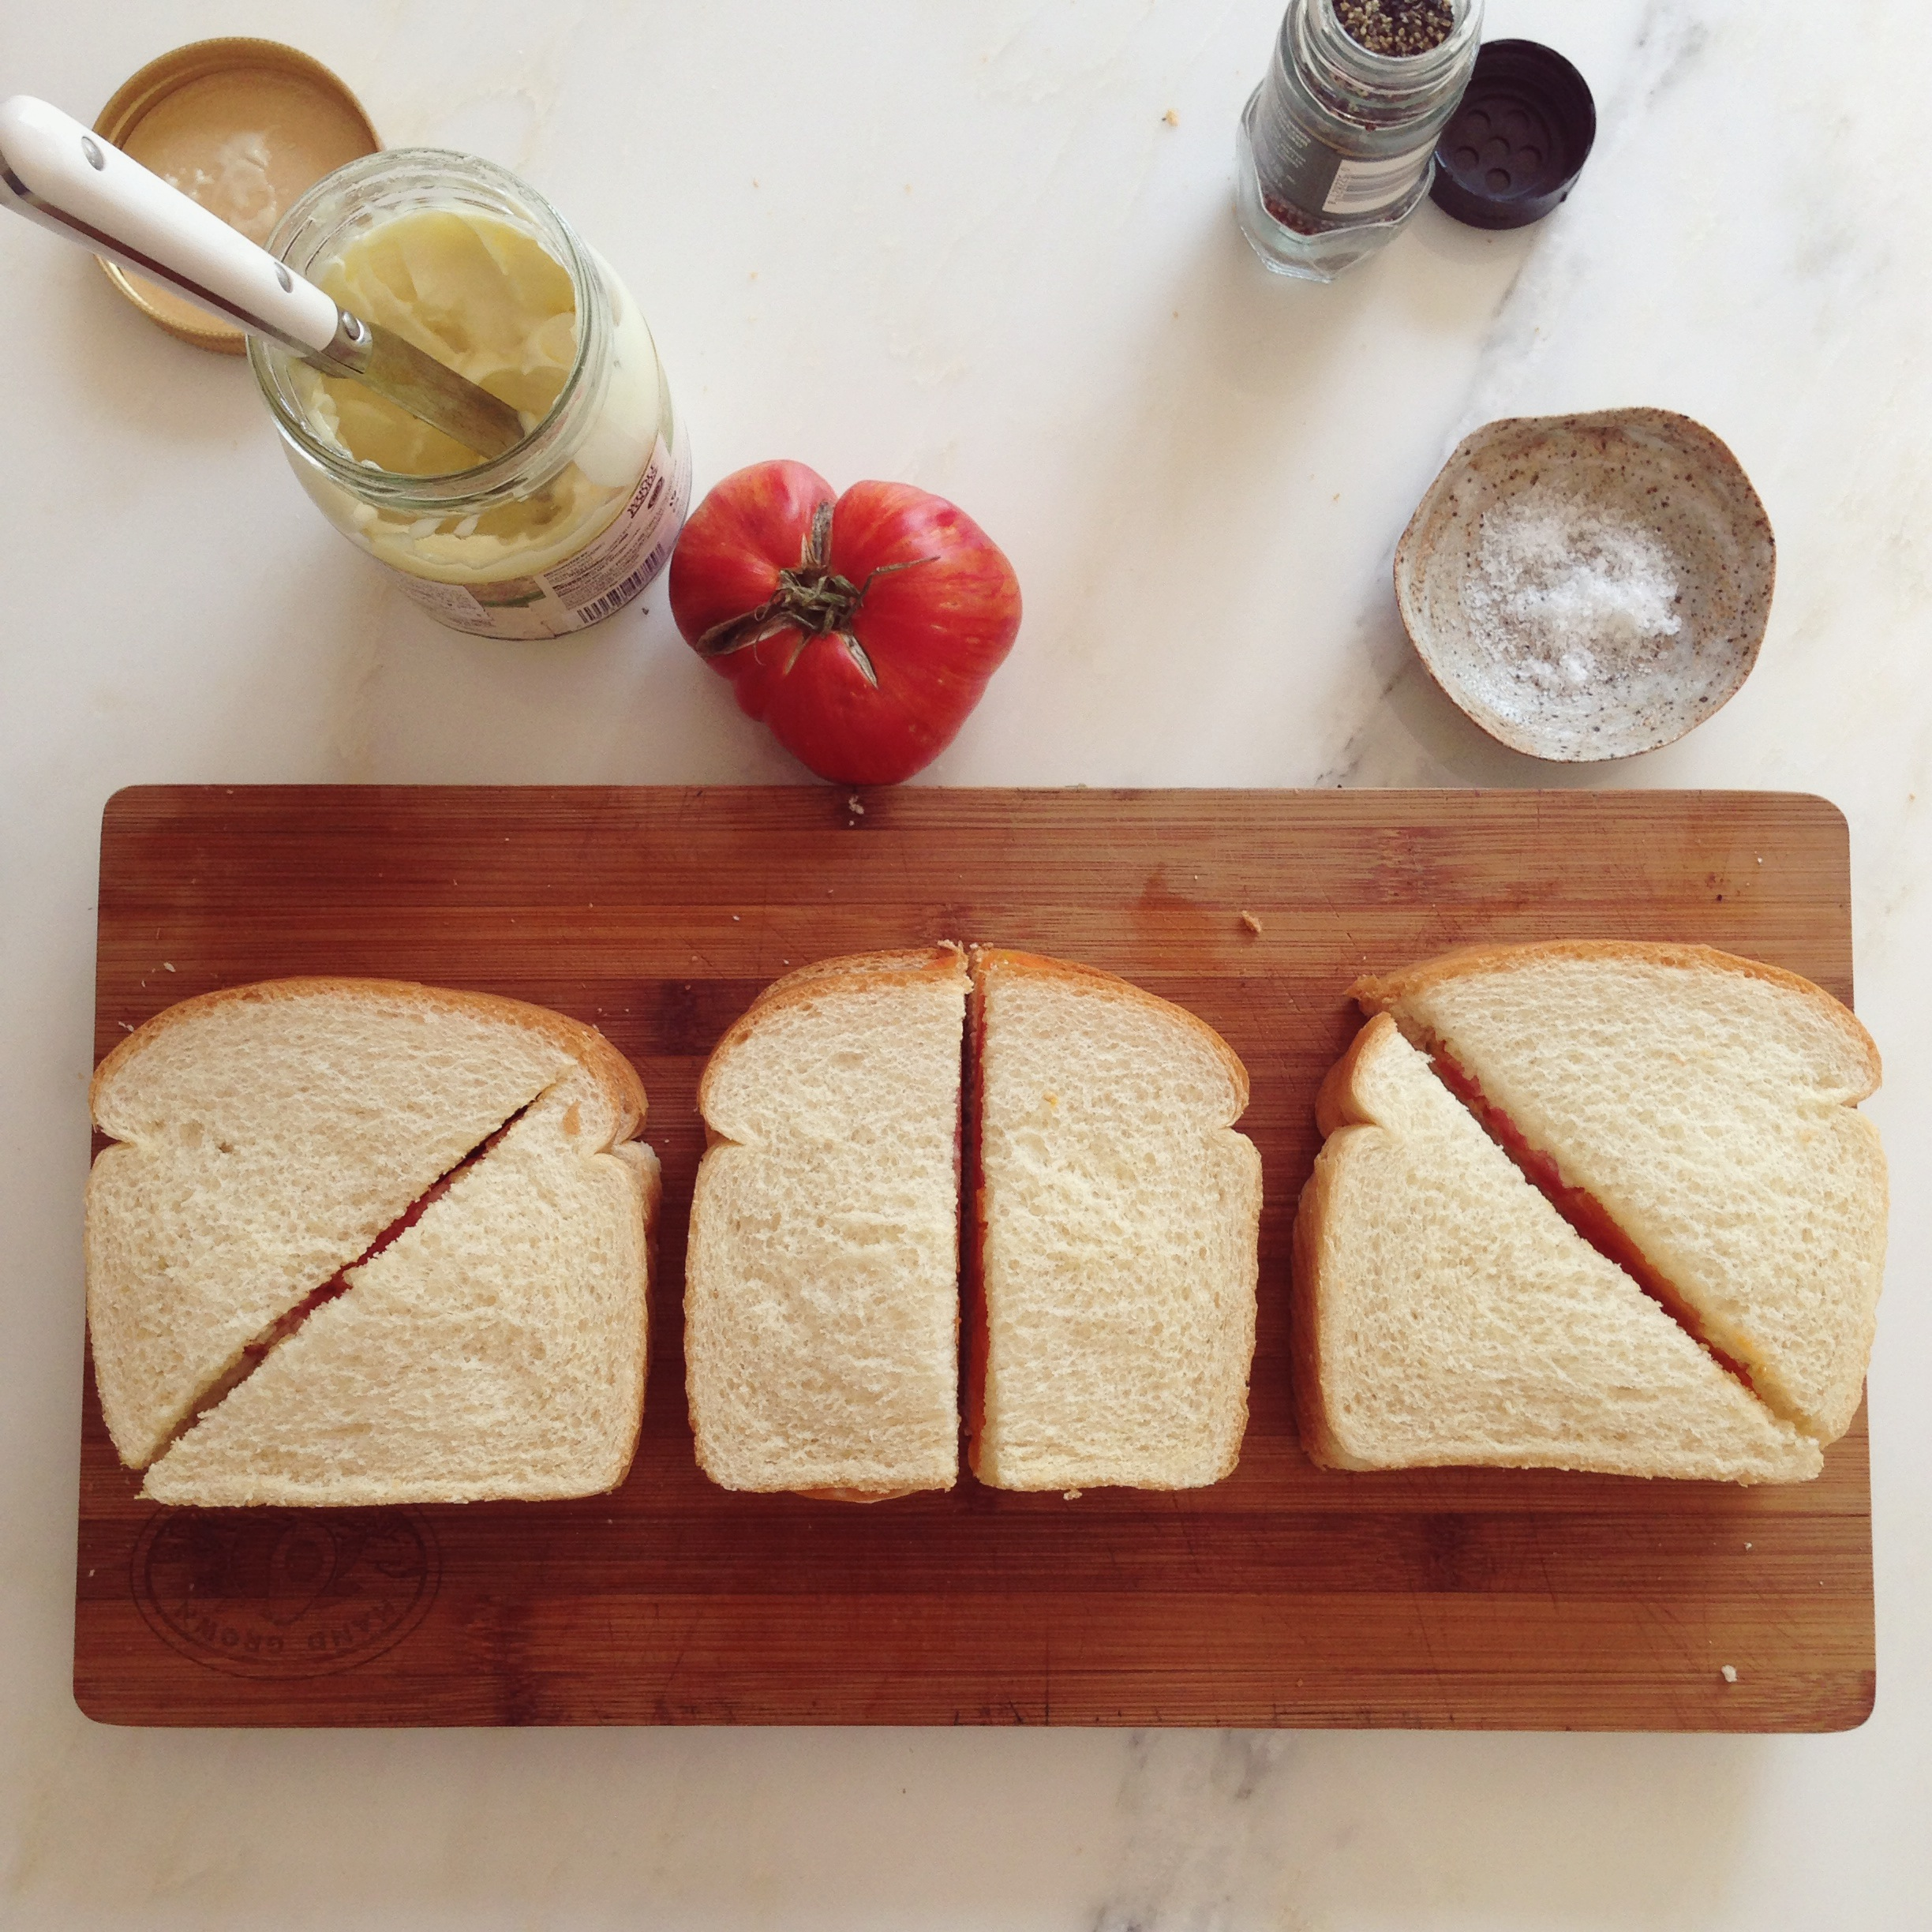
Date(s):
5. Understand the concept of halves and quarters
Date(s):
4. Identify the importance of equal sharing when splitting a whole object into smaller parts.

Date(s):
3. Split a whole object into a specified number of parts.
Date(s):
Date(s):
- Give out individual items from a set.

Progression Pathway Early Level - Fractions MNU 0-07a
Food and Health Skills Academy – HWB 0-29a / 0-30a / 0-33a

