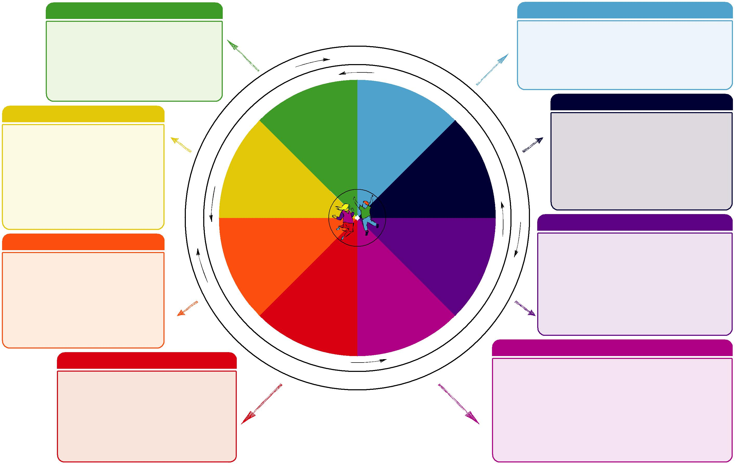

Do luchd-ionnsachaidh na h-Alba, le luchd-foghlaim Alba
For Scotland's learners, with Scotland's educators

Slàinte agus Sunnd Dleastanas na h-uile

