Why?
Parents and carers are one of the main influencers for young people when it comes to careers and pathways. This toolkit offers guidance and templates to support educators in communicating with parents, challenging perceptions with an aim to inform and support parents to better support the young people in their lives.

What should be communicated?
Suggested Key Messages:
- The world of work is changing/The Labour Market, including current and future labour market insight, where the jobs are, what employers want, the skill and qualification requirements.
- Pathways, including how pathways are changing and vocational parity and how the school curriculum is developing.
- Work Readiness, how can young people get work ready.
How can this be achieved?
- One to one conversations
- Parent events
- Career Events
- Social Media
- Newsletters
- Website
This toolkits offers guidance on key messages and offers resources to support educators in delivering these through a variety of methods. Pages 10 – 13 in this document offer further insight to the key messages to support educators to deliver this confidently.

Delivering DYW key messages to Parents and Carers
Key Message | FREE Resources available for in school use | External events taking place
The world of work is changing/The Labour Market, including current and future labour market insight, where the jobs are, what employers want, the skill and qualification requirements. | DYW School Website content template (Page 3-4)  DYW Parents Presentation for Career Event (Page 5 and Presentation template downloadable HERE)  Employer Videos (Downloadable HERE, Available from October 2019)  Social Media Campaigns and Ideas (Page 6)  Marketplace offers  DYW Website – Newsletter articles/Spotlight on young people  SDS – My Kids Career Website  National Parent Forum Scotland – In a Nutshell guides  - Skills in a Nutshell  - Digital Skills in a Nutshell  - Cyber Security Careers in a Nutshell  Marketplace Offers – Specifically Apprenticeship Ambassadors | Jobs Roadshow – Marketplace for Bookings/ DYW Website  Edinburgh College Insight – Marketplace for Bookings/Open days and wider events  Skills Scotland Edinburgh
Pathways, including how pathways are changing and vocational parity and how the school curriculum is developing. | As above and additional National Parent Forum Scotland Nutshell Guides:  - Career Education – A world of Possibilities  - Career Conversations in a Nutshell  - Apprenticeships in a Nutshell  - Learning Pathways in the Senior Phase and Beyond  - Wider Achievement in a Nutshell
Work Readiness, how can young people get work ready. | All of the above and:  Work Ready Conference event/activity template (Page 7-9 plus Downloadable presentation template HERE)

DYW School Website Content Template
It is recommended that each school have this content on their website within their careers/employability area or a DYW area with a link into parents.

The DYW Logo – should be link to website www.dyw-EdinMidEast.com

Introduction
Developing the Young Workforce (DYW) aims to develop a skilled workforce for Scotland’s future. This needs young people, parents, schools and employers to all work together so that young people can become informed, inspired and hired.
The new partnerships between education and business has led to the old routes to employment changing.
Please read below to see what you need to know!
Informed
In school young people are informed about careers, pathways, job opportunities, in demand employment sectors and the skills needed to successfully progress into & also develop within the workplace. They are then prepared for the world of work and so become Work Ready.
Businesses are involved in giving young people the right information and ideas to help them both understand and develop the necessary skills for the world of work. New pathways for young people to move into the world of work are constantly being developed between education and employers.
Find out more: Suggested Links
New pathways to employment; Foundation Apprenticeships in the Senior Phase https://www.apprenticeships.scot/become-an-apprentice/foundation-apprenticeships/
What Businesses are offering schools in my local area: www.myworldofwork.co.uk/marketplace/opportunities
Inspired
Young people should be inspired to think beyond only the jobs they know - the older and more traditional jobs, beyond gender based roles and have broader visions for career opportunities. It is up to everyone to be involved in inspiring the young workforce of the future.
Find out more: Suggested Links
What Businesses are offering schools in my local area: www.myworldofwork.co.uk/marketplace/opportunities

Hired
In Scotland there are many quality employment opportunities for young people when they leave education. This includes Modern and Graduate Apprenticeships, which enable young people to take their first step into the world of work.
Find out more: Links
Jobs, Apprenticeship’s and training programmes available locally www.theguarantee.org
Modern and Graduate Apprenticeships available local and nationally www.apprenticeship.scot
College can get you to where you want to be www.edinburghcollege.co.uk

Want to know more about Developing the Young Workforce? www.dyw-EdinMidEast.com

Suggestion for schools
We would also recommend also adding in what you are doing as a school, highlighting these activities under “informed inspired and hired” collectively.
Celebrating diverse pathways to success for young people is vital.
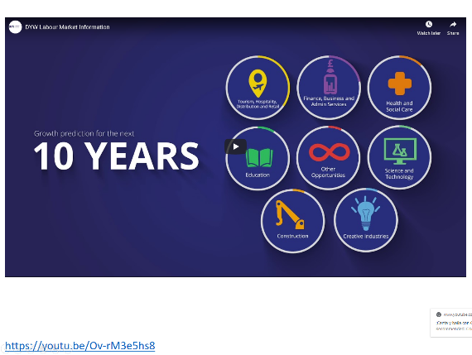
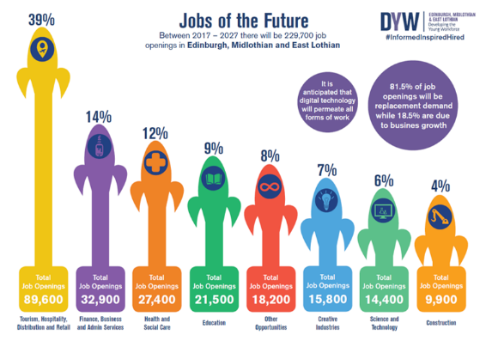
DYW Parents Presentation at Career Event
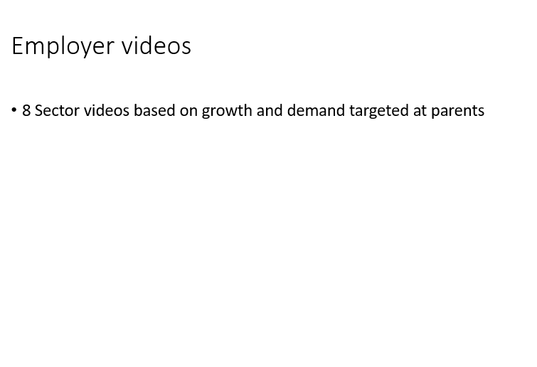
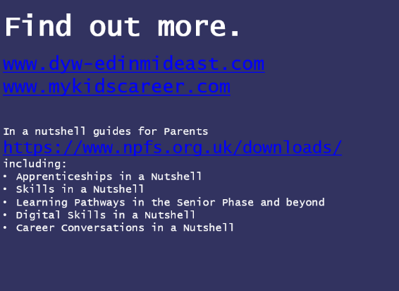
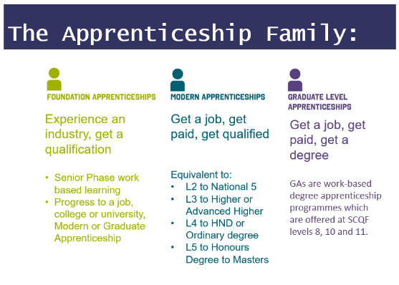
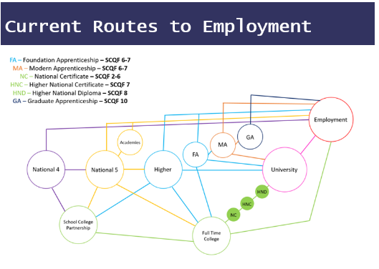
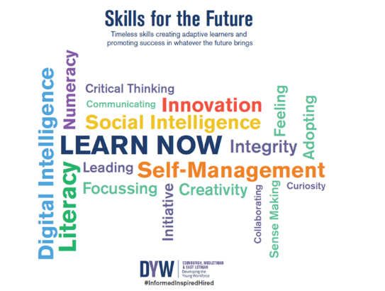
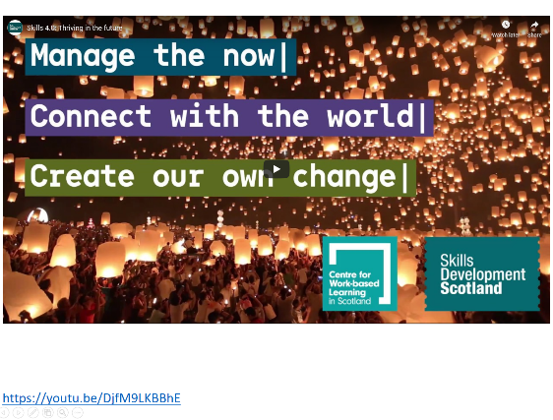
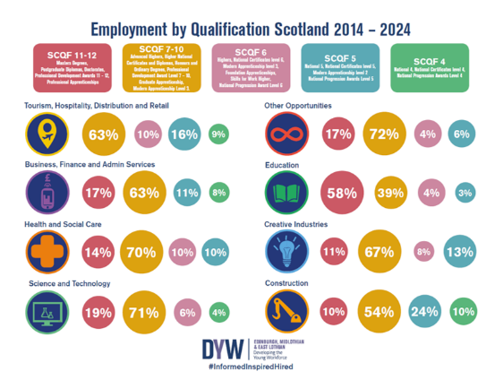
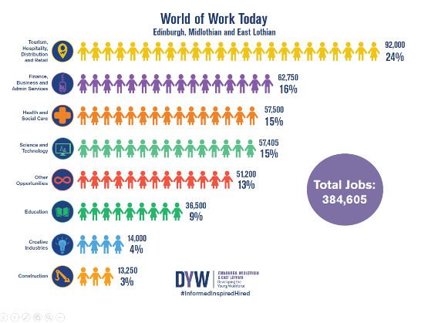
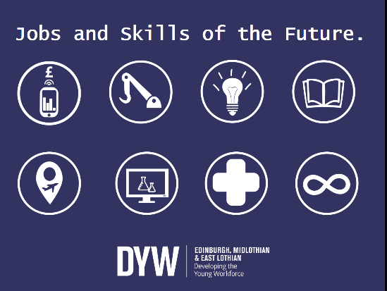
This can be enhanced by including SDS and Edinburgh College to broaden out apprenticeship and college pathways.

Social Media Campaigns/Ideas

Step 1) Follow the regional DYW group
Step 2) Follow Edinburgh College
Step 3) Follow SDS
Step 4) Get tweeting and retweeting

Campaigns and Hashtags:
#NoWrongPath Find out more about his national campaign at www.nowrongpath.scot
#InformedInspiredHired Your regional DYW employer led group use this # to profile employer and educator good practice, employer offers and events.
We have seen some great use of social media celebrating success through DYW, some example are below:

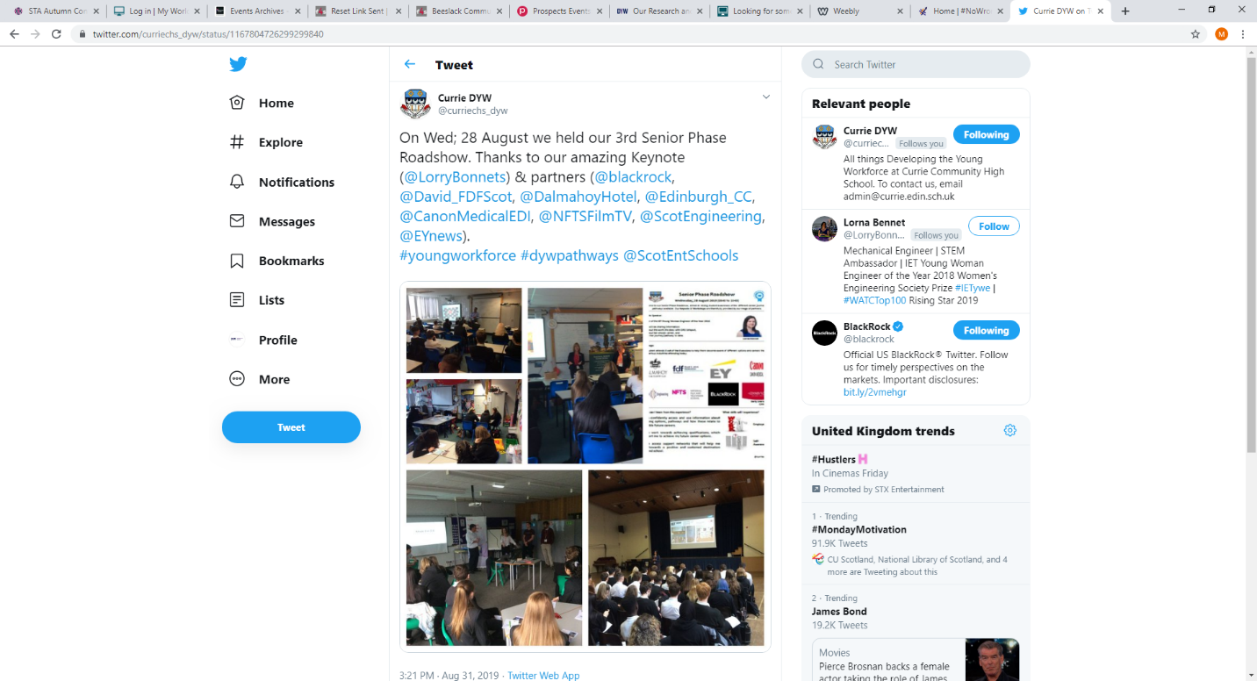
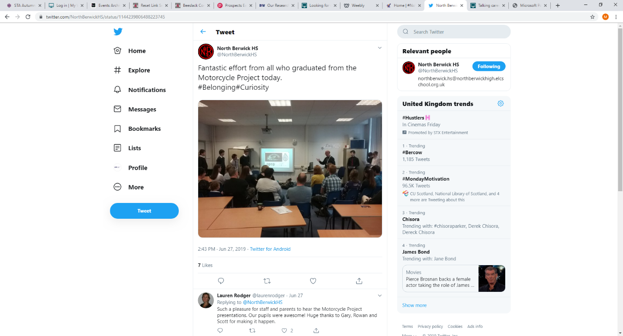
CELEBRATING DIFFERENT PATHWAYS: The tweet above involved a young person interviewing another young person on their success of getting into college.
CELEBRATING EMPLOYER PARTNERSHIPS: This tweet thanked the employer involvement and showcased partnerships and learning outcomes.
CELEBRATING DIVERSE ACHIEVEMENTS: This tweet celebrates young people completing a vocational pathway

Work Ready Conference event/activity template
Context: Much research and the experience of DYW delivery has identified key drivers and the benefits for Employers getting involved in informing and inspiring young people. ‘Work readiness’ has been identified as one of the top key drivers of employer engagement and is referenced in many ways including nurturing a talent pipeline and building the employability skills of Scotland’s future workforce. Research also suggests there is a contradiction between what employers want and what young people think employers want so the definition of work readiness varies between supply and demand.
The main aim of the conference is to raise awareness of what Work Ready really is and to inspire all stakeholders to take action. For young people and parents, the call to action is #CreateDontWait. This campaign will aim to empower young people to proactively take control of their spare time and time in education, to pursue activities which will support the development of transferrable skills for the world of work, supporting them to be ‘Work Ready’, and support parents in being involved.
Conference Purpose:
- To share findings on the DYW regional ‘Work Ready’ research
- Raised awareness for all on diverse learning activities that feed into learning for life and work.
- To challenge perceptions of work readiness with delegates offering clarity and a unified understanding.
- To stimulate discussion and learning with all stakeholders so each delegate gets a ‘Take Away’ or ‘Call to Action’ around ‘Work Readiness’
- To share stories of young people and employers around work readiness.
- Wider achievement gains the recognition it deserves in developing skills for work readiness.
Objectives: By attending the conference:
- Young People will know what it means to be work ready, understand how they can become work ready and be inspired to take action
- Educators and parents will know what it means to be work ready and the needs of employers when seeking work ready young people. Know how they can support Young People to be work ready and be inspired to take action
- Employers will know how they can help Young People to become work ready, know how to translate good practice into action in talent attraction and recruitment and be inspired to take action

Template for Work Ready Event Delivery
Timing | What | Resource | Who | Key Messages
20 minutes | Registration | Welcome Slide | School | Hand out details of what will happen at the event
15 minutes | Welcome and Introduction  Icebreaker  Scene Setting  Research Findings | Work Ready  (Icebreaker ideas) Presentation  (Can also incorporate DYW Presentation for careers events) | School | Welcome to the school and event  Icebreaker to warm up the audience  What will happen today  Headline details on Work Readiness
30 minutes | Fire side Chat  Discussion with young people in work (Alumni if possible) and employers. | Fireside Chat Template and guidelines | Facilitator  Employers/Young Employees  Marketplace Apprentice Ambassadors  Alumni  Audience | What is Work Readiness according to young people and employers  The real stories of routes into employment  #NoWrongPath  What needs to change
30 minutes | Carousel Activity with employers/Young people | Fact Finding Quiz | All | Opportunities available for young people  Pathways and progression  Skills for Work Readiness
25 minutes | Discussion and Close | Presentation | All  School | Table facilitators draw out key learning.  Thank you, what is next?

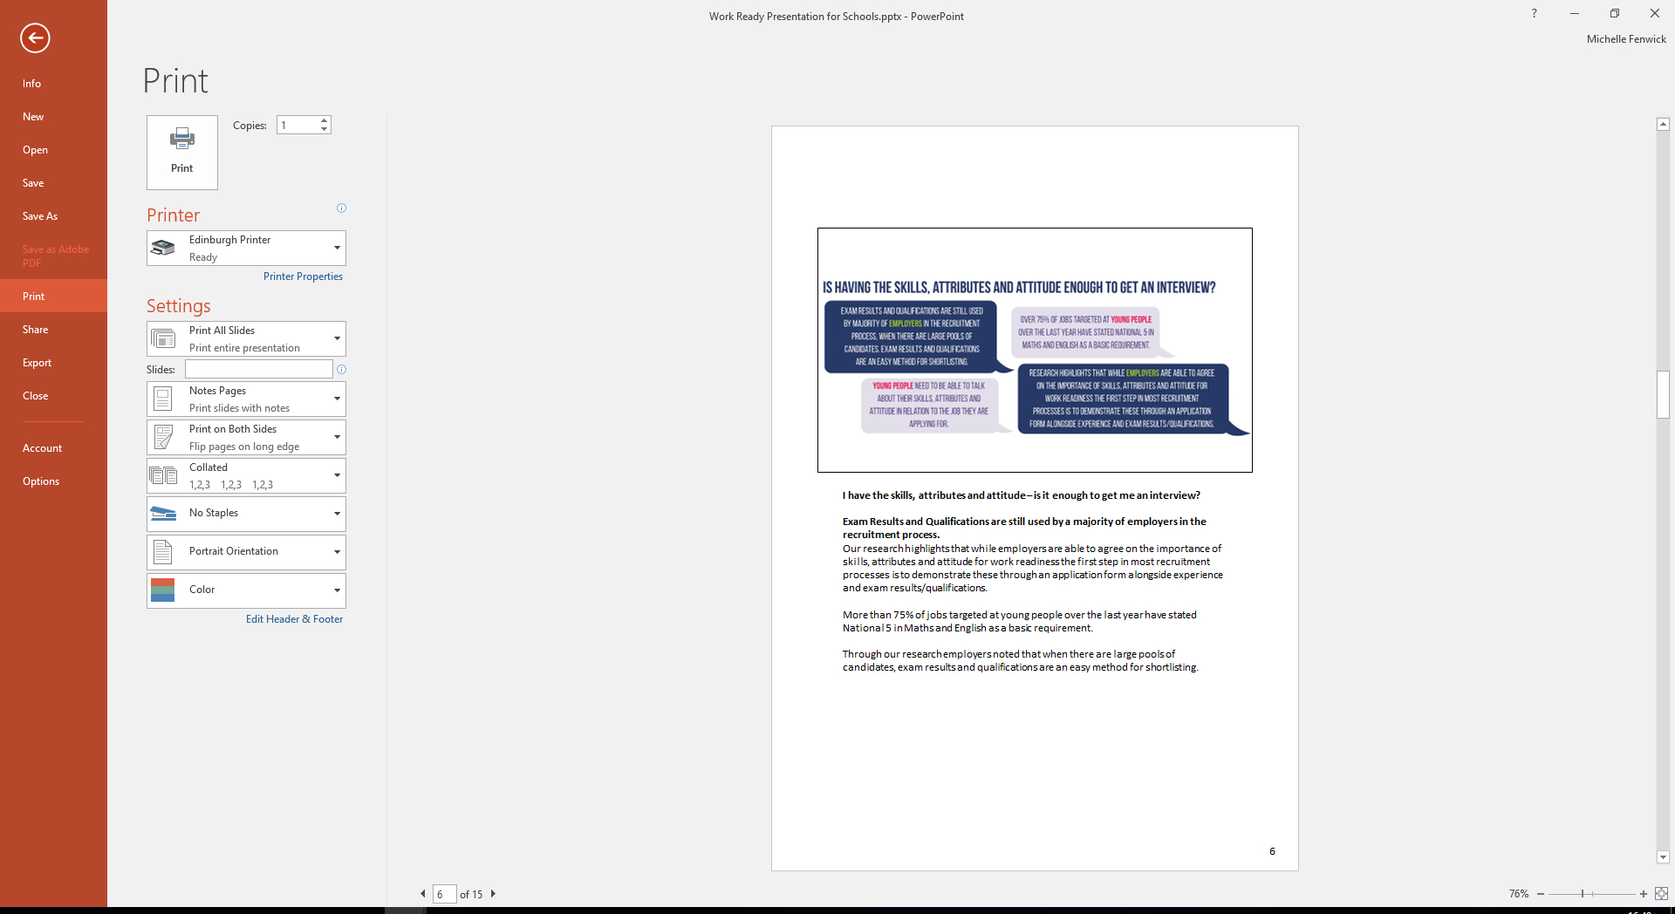
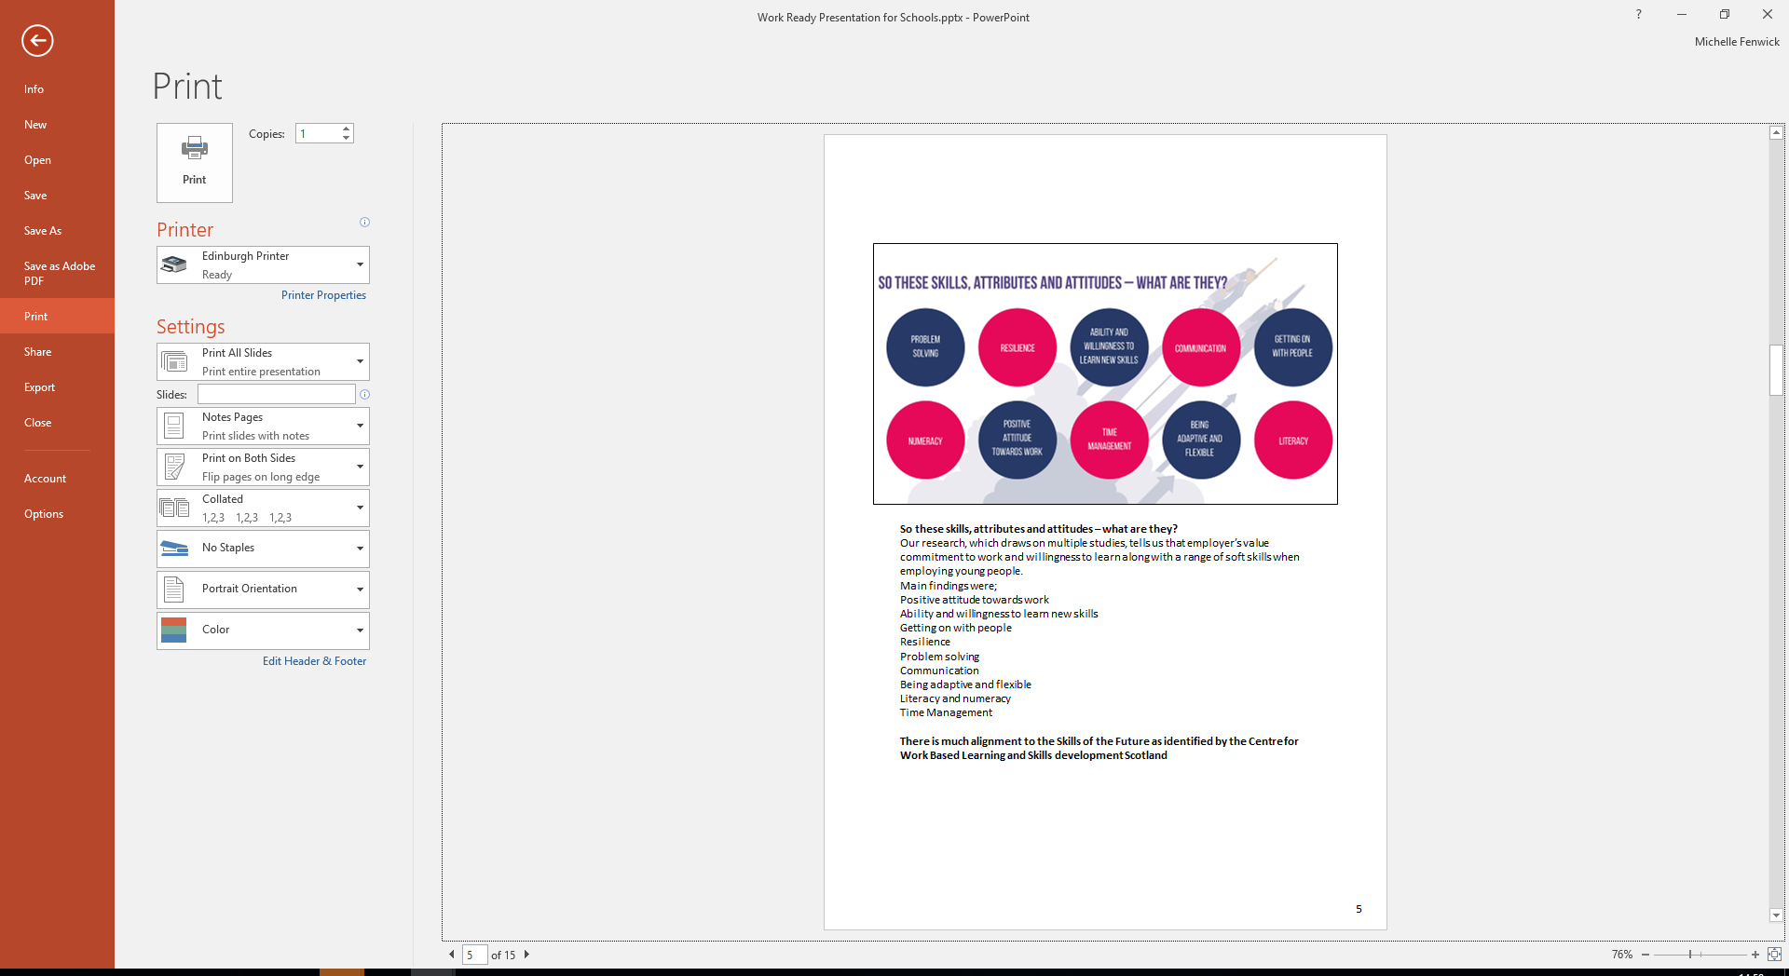
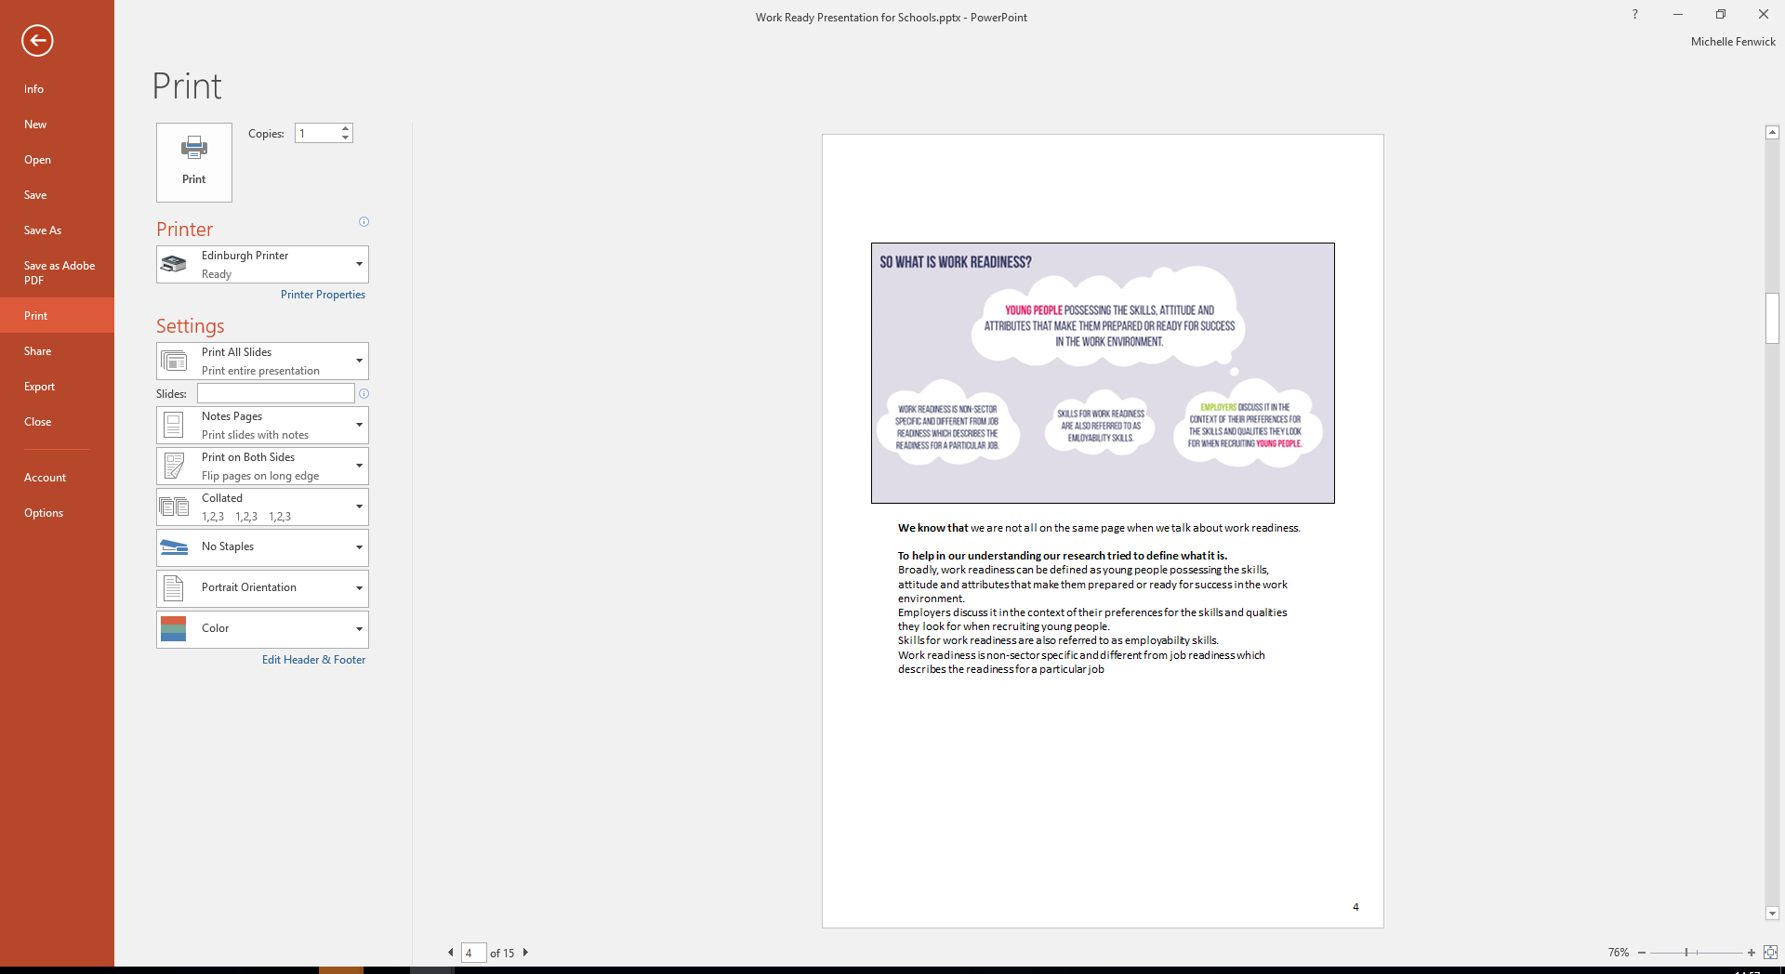
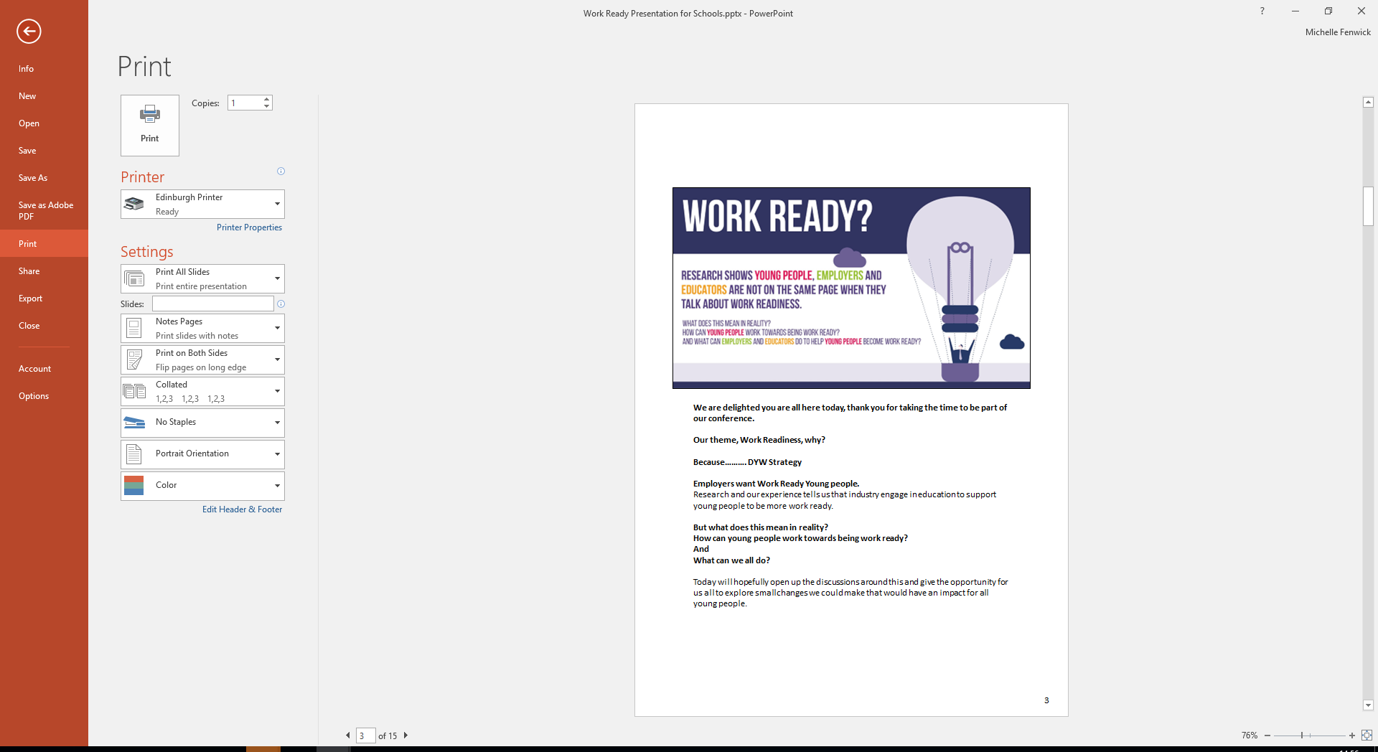
Work Ready Presentation
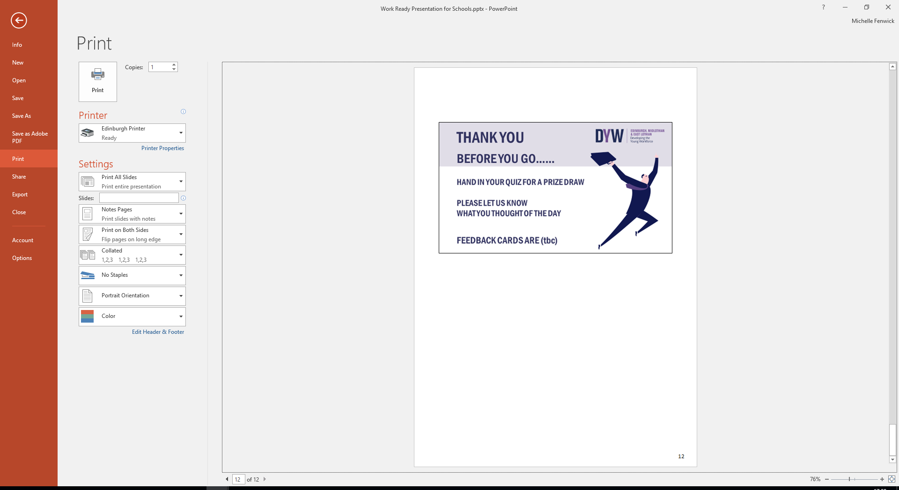
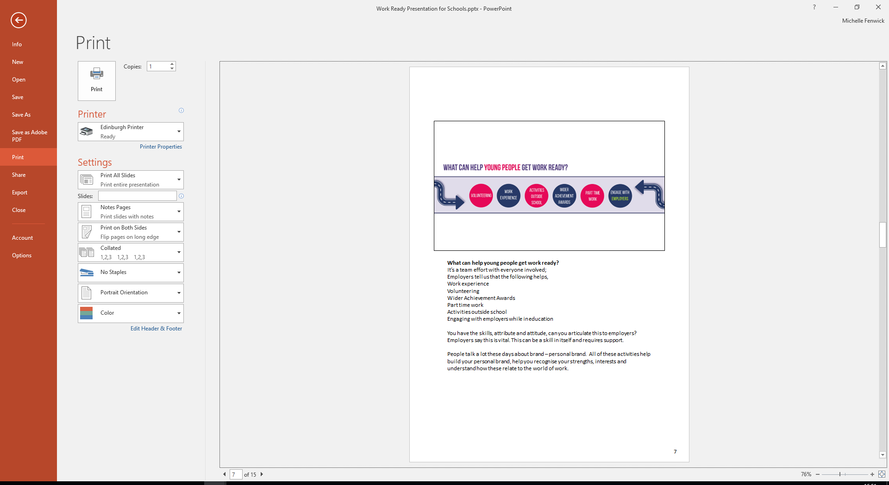
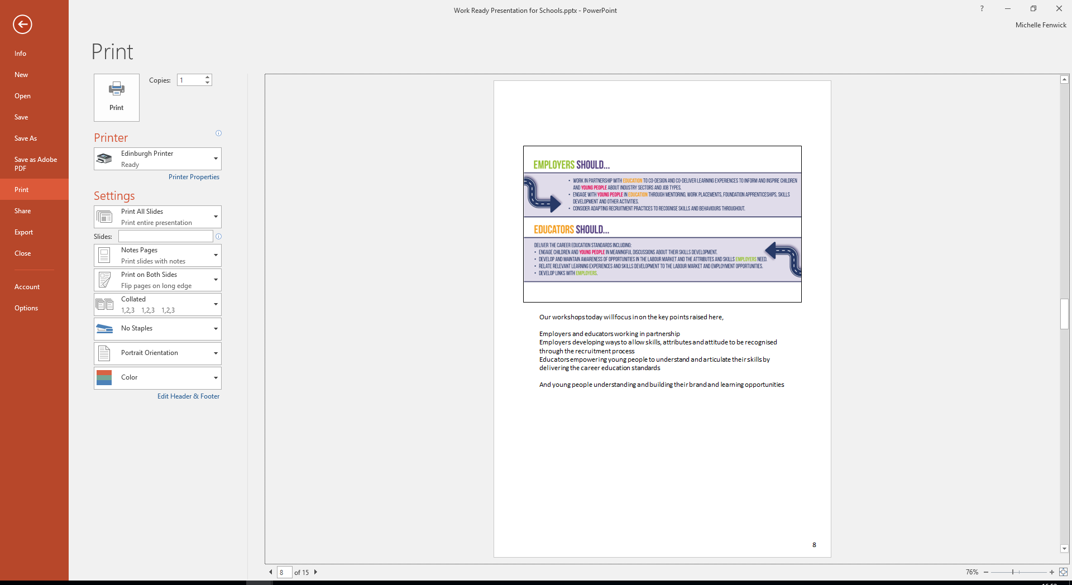
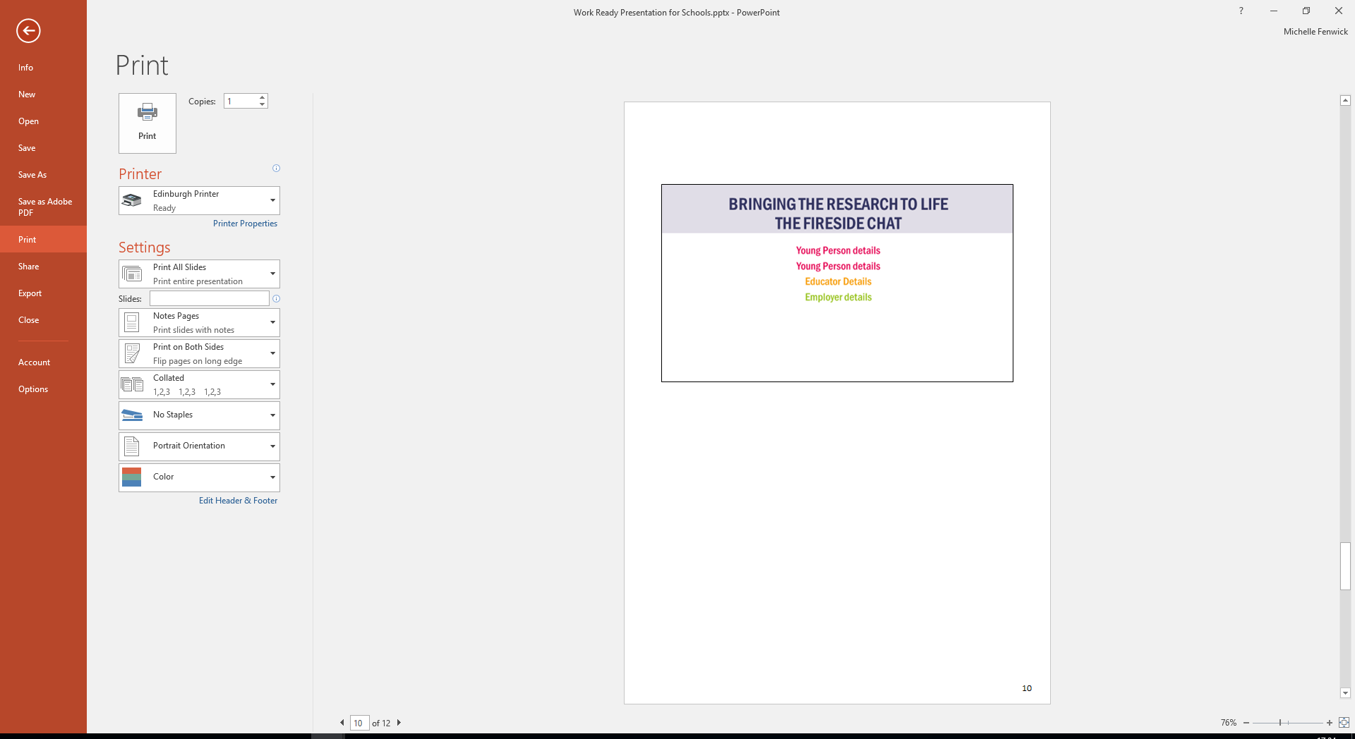
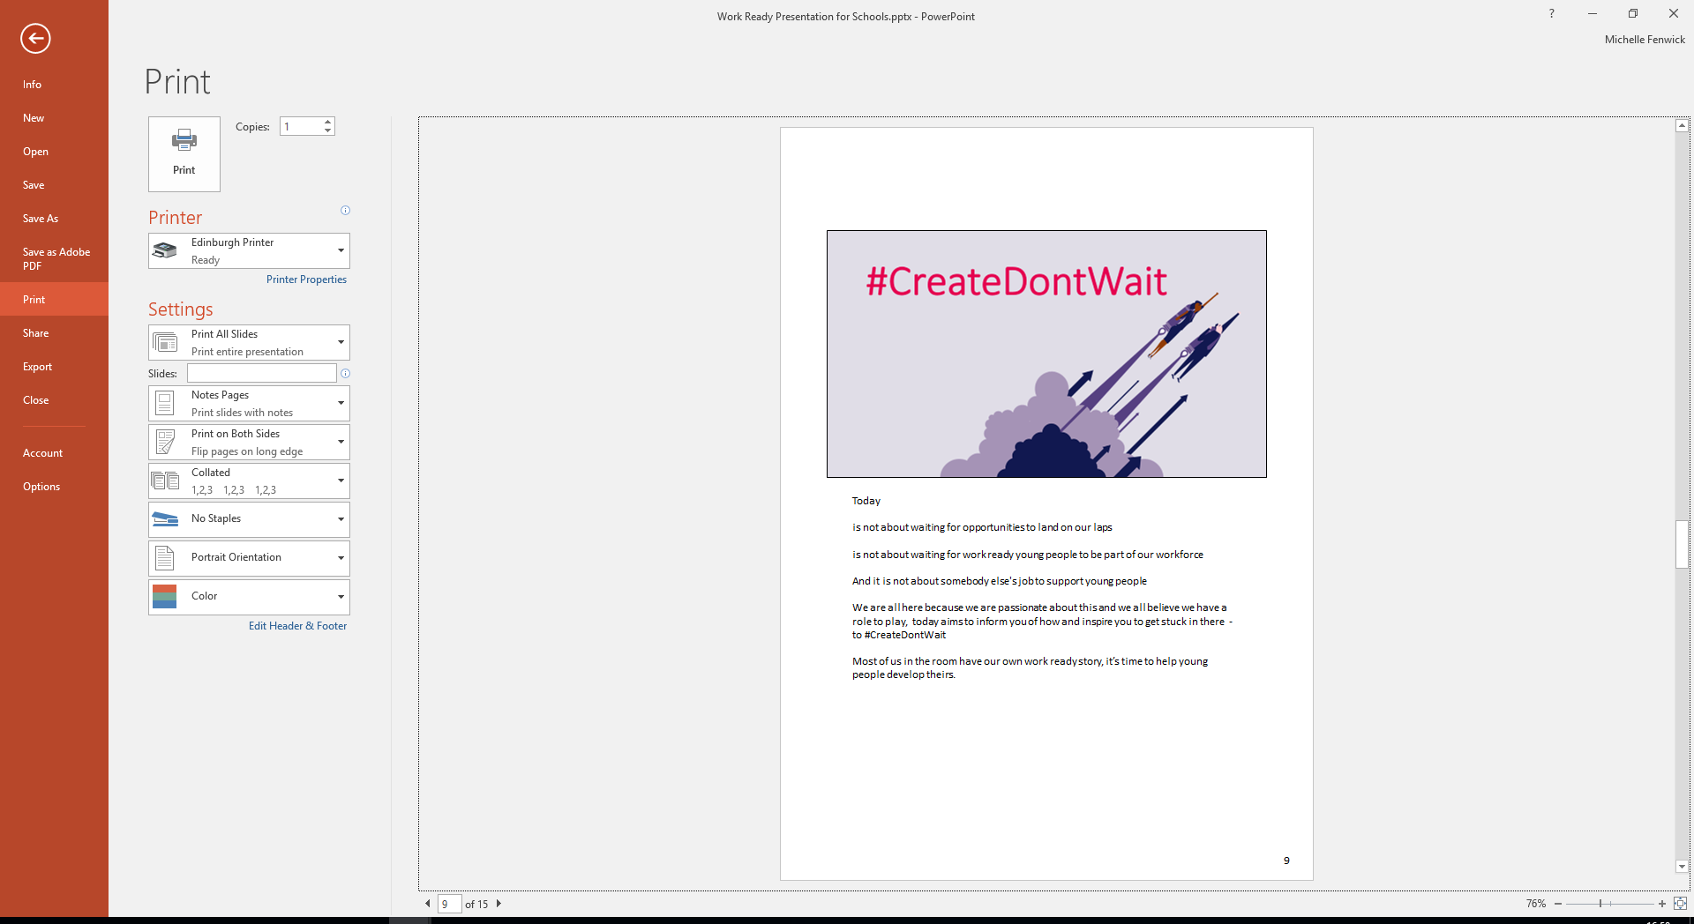

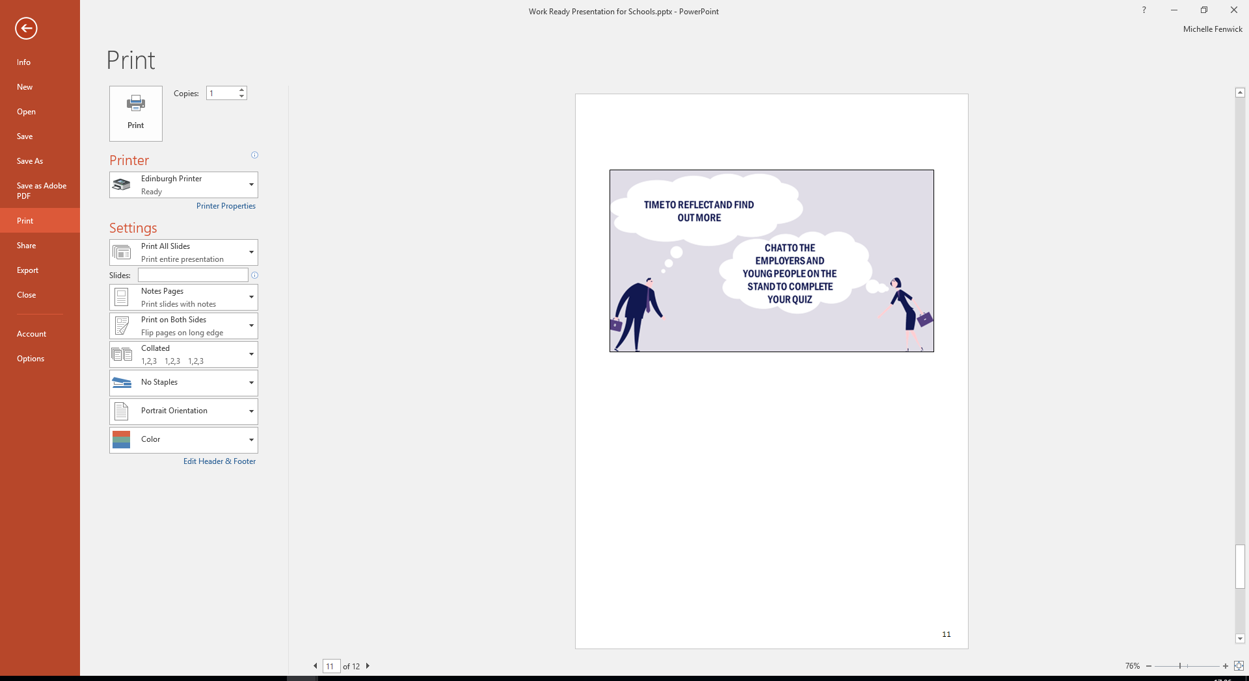

Key Messages: Additional Insight for Educators
Pathways, including how these are changing and vocational parity.
What parents know to be traditional pathways to employment are changing. Vocational qualifications and pathways deserve absolute parity alongside academic qualifications and pathways. A barrier to young people harnessing vocational pathways, we believe, is generational and is based on what apprenticeships mean to those whose children are currently making career choices. Foundation, and Graduate Apprenticeships now provide economically interesting options to reach the same earning and qualification potential.
Apprenticeships give your child the chance to get hands-on experience with an employer, and work towards a qualification at the same time. They'll learn by doing and pick up valuable employability skills, like time management and team working, too.

Key Points:
- Traditional pathways to employment have evolved creating more vocational routes for young people to progress and develop the skills employers are looking for.
- There are three different types of apprenticeship in Scotland. Foundation, Modern and Graduate Apprenticeships, meaning no matter what stage your child is at, an apprenticeship can help them towards their future career.
- They’re an opportunity to gain industry experience and work towards a qualification at the same time.
- Foundation Apprenticeships are delivered in the senior phase at school and are the equivalent of Highers, offering a pathway to employment or further and higher education.
- Modern and Graduate Apprenticeships are a great way for young people to gain skills while working – ‘earning while learning’.

More Information:
- There is no wrong path. The step a young person chooses to take after school does not define their whole career but is a stepping stone to the next opportunity. There are different routes to the same destination, some slower and some faster - but none are wrong.
- In the early 60s only 4% of school leavers went to University. By the end of the 70s 14%, and now sits around 40%. The number of academic institutions and courses have also increased, yet jobs requiring a degree have not increased in line with this.
- Graduates of Business and Administration may find that even if they work in an associated role it may not be one that requires a degree, leading to underemployment. Typically 34% of Business and Administration graduates will be in this situation. The average salary for a professional role in this area for a graduate is currently £18,000 compared to a Scottish Government Modern Apprenticeship Business Administration at £18,392.
- On speaking to businesses they are clear that first and foremost they need to recruit young people with the right attitudes and attributes. They are not selecting simply on the basis of academic ability. These soft skills, it could be argued, are gained in the workplace or through vocational learning more quickly.
- Scottish apprenticeships provide flexible, practical opportunities for young people to pursue work-based learning that suits their needs, goals and aspirations, while giving them first-hand experience of the world of work.
- Foundation Apprenticeships take two years to complete and usually start in fifth year along with Highers and National 5s. Your child will spend time away from school and study at college, as well as getting work experience with an employer.
- There are 12 different kinds of Foundation Apprenticeship. Your child will get out of the classroom and get work experience with a real employer in areas such as business skills, civil engineering and scientific technologies. Find out more about the different kinds of Foundation Apprenticeship on Apprenticeships.scot
- Modern Apprenticeships are an option for your child if they’re leaving school. They’ll learn on the job and work towards a qualification – while getting paid too.
- There are around 80 different types of Modern Apprenticeship. Your child could start their career with an apprenticeship in areas like science, healthcare, IT and digital, finance, fashion, arts, engineering, construction and renewable energy. Find out more on Apprenticeships.scot. By using their My World of Work account, your child can also find Modern Apprenticeships that would suit their skills, strengths and interests
- Graduate Apprenticeships will give your child the chance to work, get paid, and get a degree at the same time. They’ll spend most of their time learning on the job, but will also be a student at a university or college.
- Graduate Apprenticeships are expanding. In 2018 there will be 11 courses on offer at 12 different universities and colleges. Keep up-to-date on Apprenticeships.scot
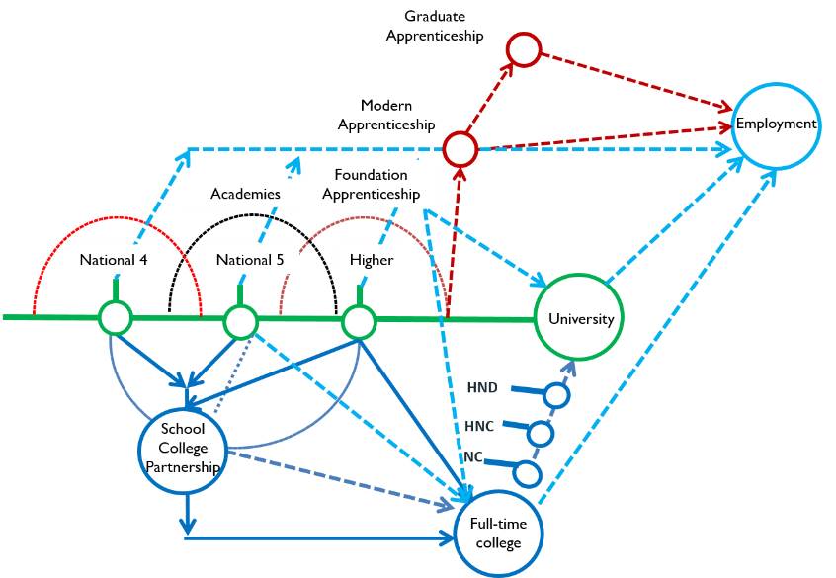
Traditional Routes to Employment Current Pathways to Employment
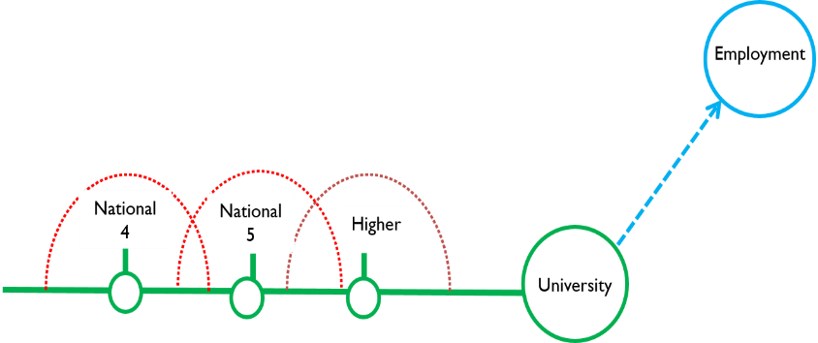

The Labour Market, including current and future labour market insight, where the jobs are, what employers want, the skill and qualification requirements.

The labour market is the availability of employment and labour in terms of supply and demand, what industry wants and needs and who is available for work. More broadly this includes the skills and knowledge people have and how these fit with the requirements of industry. Sometimes we see a mismatch of skills supply and demand leading to skills gaps and demand for talent from wider pools. This mismatch can also lead to underemployment, where too many people have knowledge or skills in an area where there is little or no demand.

DYW supports industry to ensure the curriculum reflects the labour market and young people have an educational experience reflective of skills and knowledge demand from industry.

Key Points:
- DYW offer Labour market insight to parents, educators and young people.
- The next 10 years there will be over 229,700 job openings in our region.
  - 89,600 job openings within Tourism, Hospitality, Distribution and Retail
  - 32,900 job openings within Finance, Business and Admin Services
  - 27,400 job openings within Health and Social Care
  - 21,500 job openings within Education
  - 15,200 job openings within the Creative Industries
  - 14,400 job openings within Science and technology
  - 9,900 job openings within Construction
  - And approximately 18,200 job openings in other opportunities

More Information:
- Between 2017 and 2027, there will be approximately 229,700 job openings in Edinburgh, Midlothian and East Lothian. 81.5% of these will be replacement jobs and 18.5% will be due to growth in the economy.
- There is an evolution of existing jobs taking place in Edinburgh, Midlothian and East Lothian – new tasks, new knowledge and skills requirements, and changing work patterns. It is anticipated that Digital skills will permeate all sectors.
- The pathways to these jobs are also evolving, the Apprenticeship Family opens up a variety of opportunities to progress into careers vocationally.
- Engagements between industry and education creates opportunities for work inspiration which brings the world of work to life for young people in and out of the classroom, supporting the development of skills and knowledge while broadening horizons for young people.
- Positive destinations in our region are improving year on year, young people in East Lothian and Midlothian are more likely to progress straight into employment from school than young people in Edinburgh.
- Up to date data like Positive destinations and participation measure would be valuable when presenting on the Labour Market.

DYW LMI can be found on the Educators pages on the DYW Website
Work Readiness:
Full report can be found at https://www.dyw-edinmideast.com/our-research-and-reports.html
The DYW Website parents page is full of insight on Work Readiness based on the report.

