

Lesson Study in Numeracy
Planning for Cluster Peer Visits

Session 2016 – 2017
14th October 2016

Planning 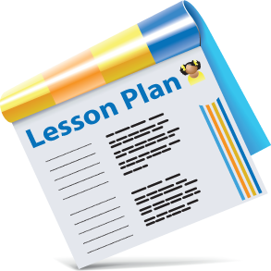
Identify specific lesson goals (these goals often come from examination of
assessment data or identifying a common issue/ problem)
• Select or revise research lesson
• Anticipate student responses
• Plan data collection and lesson

Do Research Lesson 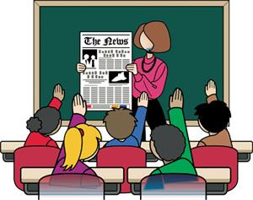

• One person teaches the lesson
• Observers note pupil actions and responses
• Collect evidence of pupil thinking
• Purpose is to gather data on effectiveness of the lesson not to evaluate the teacher
Reflect (later revise and re-teach) 
• Discuss the lesson and observations and share evidence of student learning
• Based on the evidence collected and discussed the team makes changes to the lesson
• Changes are designed to address issues and student misunderstandings within the lesson
• This may involve several meetings and reiterations
• Lesson then re-taught to a new group of pupils
• Disseminate the findings of the study
• Use the knowledge generated to inform practice in other areas

