ASPIRING TO MIDDLE LEADERSHIP
EDUCATION SCOTLAND
ASPIRING TO MIDDLE LEADERSHIP

REFLECTIVE JOURNAL


Aspiring to Middle Leadership
  - Reflective Journal
This Reflective Journal has been designed to be used with the Aspiring to Middle Leadership open access programme. It is intended as an optional support and is not for submission.
If you use this template and think there is anything that we need to add, remove or change please get in touch by using the contact details included in the programme.
We hope you enjoy the programme.
Contents
How to use this Reflective Journal 1
Introductory activities 2
Reflections on dialogue with my peer supporter (1) 5
Reflections on the Roles of Middle Leadership PLAs 6
Reflections on dialogue with my peer supporter (2) 7
Initial reflections on inclusion 7
Reflections on Inclusion, Wellbeing and Equalities PLAs 8
Reflections on dialogue with my peer supporter (3) 9
My reflections on completing the programme 10
My next steps 10
Completion and certification 11

How to use this Reflective Journal
A reflective journal is where you record your thoughts and your reactions to the learning. Your journal is personal to you and could be a physical or virtual notebook, voice-recordings saved on your phone, or even sketching in a scrapbook.

Reflection is a purposeful activity in which you analyse experiences, or your own practice, skills and responses in order to learn and improve.

Reflecting can involve:
- scrutinising an experience and the way you dealt with it
- evaluating a project or experiment and considering how to do it better next time
- reflecting on things you have read/heard/listened to (such as programme events) and linking theory with practice/lived experience.

To support your reflection process, you can use the following guide: Short-Guide-Reflective-Writing.pdf (birmingham.ac.uk)

Introductory activities
As you work your way through the AML Introductory Activities, record your reflections below:

Activity 1: Blog by a past participant

Reflective prompt: Think back to your most recent Professional Review and Development (PRD) discussion and/or your current professional learning plan if you have one. How will participation in Aspiring to Middle Leadership support aspects of your development over the coming year?

Activity 2: The Standard for Middle Leadership

Reflective prompt: Have a think about who you are as a teacher/educator and as an aspiring leader. How do you see the Professional Values reflected in your day-to-day practice with learners, colleagues and families? What qualities might you bring to a middle leader role?

Activity 3: The Roles of Middle Leadership

Reflective prompt: What resonated with you the most from the model of middle leadership? What are you interested in finding out more about? Which of the roles do you have experience of and which do you want to learn more about?

Activity 4: Self-evaluation wheel

A self-evaluation wheel is a valuable tool for supporting self-evaluation. Using a wheel can help you to explore your current reality and critically reflect on yourself as a professional and your practice. It can support you to create clarity about the areas of learning you wish to focus on and perform a simple gap analysis about where you are now, and where you would like to be. You can use it independently or as part of a dialogue with your Peer Supporter if you have one.

Right click on the chart below then click on ‘Edit Data’. Use the table which should open to score yourself out of 10 for each role where:
- 0 = not confident/lots of areas to develop or work on/no experience of this role
- 10 = very confident/accomplished in this area/lots of experience of this role
Once you’ve scored each role out of 10, close the table and the results should appear on the chart below:

If the chart above doesn’t work for you, you could print and use the version below, completing the empty boxes with the 8 roles of middle leadership as shown above:
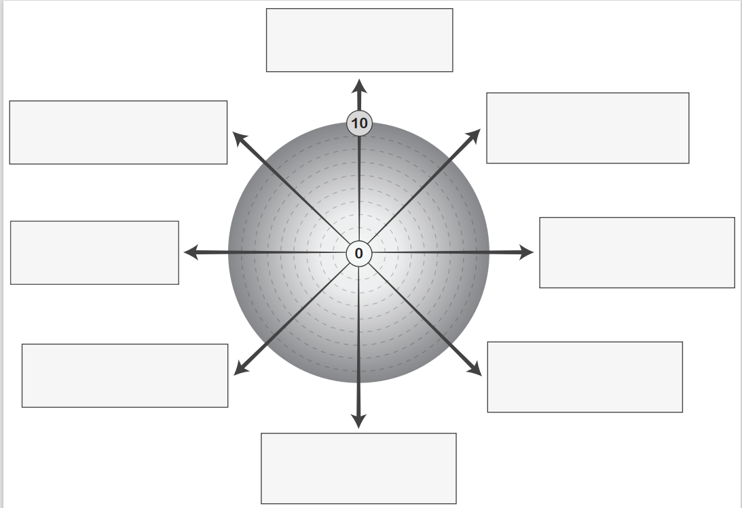

Reflective prompt: Think about ‘why’ you place yourself on that point on the scale. You may want to make some notes on the side. Join the dots around your wheel.
Looking at your completed self-evaluation wheel and ask yourself:

- What do I notice?
- What’s most important?
- What stands out?
- What’s the gap?
- What’s my priority?
- What’s a key strength?
- How might these roles impact on each other?
- Which 2 PLAs do I want to focus on?

Reflections on dialogue with my peer supporter (1)
If you have identified a Peer Supporter you may find it useful to record your reflections here during or after your initial meeting.

Date:
Reflective prompts: Use the first meeting to discuss the Introductory Activities and your hopes and expectations for the programme as well as the outcomes of your Self-Evaluation Wheel.

Reflections on the Roles of Middle Leadership PLAs
Select 2 of the Roles of Middle Leadership PLAs and record your reflections here.

PLA 1 Title:
Date completed:

Reflective prompts: What resonated with you the most from this PLA? How does it relate to your setting? What else do you need to find out? What actions will you take forward as a result of this PLA? Who can help you?

PLA 2 Title:
Date completed:

Reflective prompts: What resonated with you the most from this PLA? How does it relate to your setting? What else do you need to find out? What actions will you take forward as a result of this PLA? Who can help you?

Reflections on dialogue with my peer supporter (2)
If you have identified a Peer Supporter you may find it useful to record your reflections here during or after your second meeting.

Date:
Reflective prompts: Use the second meeting to discuss the PLAs you have completed on the Roles of Middle Leadership and what you have gained from them. How does the learning relate to your setting? What else might you need to find out? Who might support you?

Initial reflections on inclusion

Date:
Reflective prompts: What does inclusion mean to you? What does inclusion look and feel like in your setting?
- for learners?
- for you and your colleagues?

Select 2 of the Roles of Middle Leadership PLAs and record your reflections below.

Reflections on Inclusion, Wellbeing and Equalities PLAs
PLA 1 Title:
Date completed:

Reflective prompts: What resonated with you the most from this PLA? How does it relate to your setting? What else do you need to find out? What actions will you take forward as a result of this PLA? Who can help you?

PLA 2 Title:
Date completed:

Reflective prompts: What resonated with you the most from this PLA? How does it relate to your setting? What else do you need to find out? What actions will you take forward as a result of this PLA? Who can help you?

Reflections on dialogue with my peer supporter (3)
If you have identified a Peer Supporter you may find it useful to record your reflections here during or after your third meeting.

Date:
Reflective prompts: Use the third meeting to discuss the PLAs you have completed on the Inclusion, Wellbeing and Equalities and what you have gained from them. How does the learning relate to your setting? What else might you need to find out? Who might support you?

My reflections on completing the programme
If you have completed a minimum of four PLAs, it’s time to reflect on what you have learned. Read over your previous reflections and summarise the main points here. Add to these if you wish.

Date:
Reflective prompts: What have been your main points of learning from the PLAs (and sessions if you attended)? How can you share what you have learned with others? What has been the overall impact of the programme on you as an educator? On your learners? What have you learned about yourself as an educator/a leader?

My next steps
Reflecting on all you have learned, what do you now think are your next steps? You may wish to look back to your Self-Evaluation Wheel at this point and perhaps score yourself again in a different colour (remember to date it) and/or have a final meeting with your Peer Supporter if you have one.

Date:
Reflective prompts: Do I still aspire to be a middle leader? Why/not? What are my learning needs now? How do these relate to the needs of my learners? What might I do to meet these learning needs? Who can support me in my learning?

Completion and certification
Congratulations on completing the programme! If you wish to receive a certificate, you should:
- have completed a minimum of four Professional Learning Activities (PLAs)
and
- send your completed AML Learning Summary (not this Reflective Journal), naming the document using the format ‘AML First Name Second Name Month Year’, e.g., ‘AML Jane Smith June 2025’ where the date is the date of submission, and send it to PLsubmissions@educationscotland.gov.scot.
- Please allow 8 weeks for your digital certificate to arrive. If you have not had a response within that time, please contact us at edspll@educationscotland.gov.scot

_________________________________________________________________________

Last updated: June 2024

