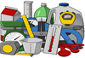
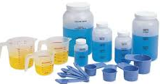

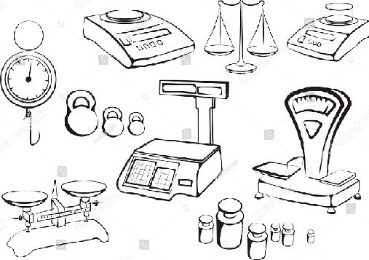
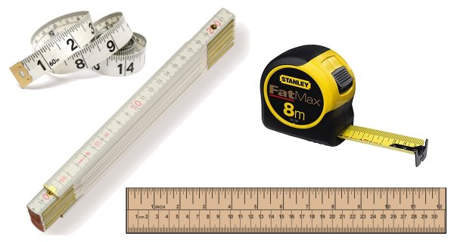
Use a simple 2-pan balance to weigh items and describe which are heavier, lighter, about the same.
Place objects in order according to weight.

Understand and use: empty, full, holds more/most, holds less/least.

Understand and use comparative language for weight: heavyheaviest, lightlightest, about the same.

Achieving
Progressing well
Making progress
Understand the concept of volume with regard to filling containers with liquids and solids
Describe capacity using “full” and “empty”.
Describe weight using “heavy/heavier” and “light/lighter”

Place objects in order according to length, height
Understand and use length vocabulary to compare and describe size: long longest, shortshortest, thick thickest, thin thinnest.

Describe length using “long/longer” and “short/shorter”

Progression Pathway Early Level - Measurement MNU 0-11a
Food and Health Skills Academy – HWB 0-29a / 0-30a / 0-33a
Length:

Weight:

Capacity:

